Note: Trigger and Echo pin to any digital pin on the Arduino board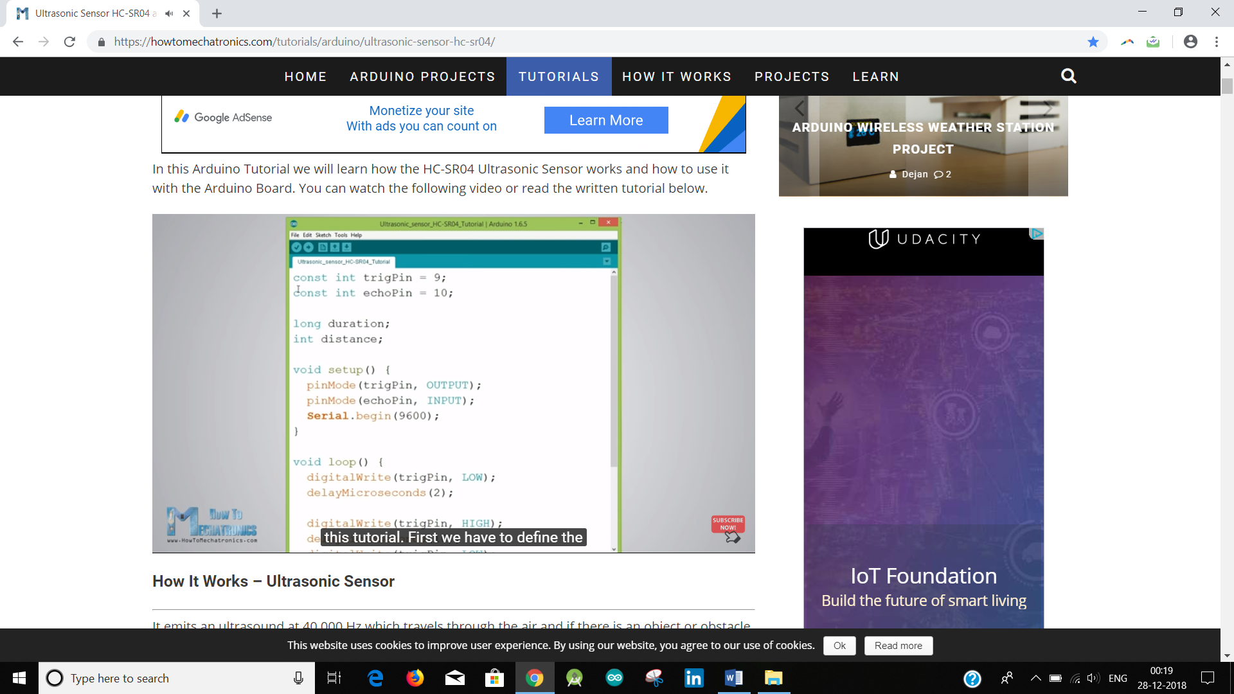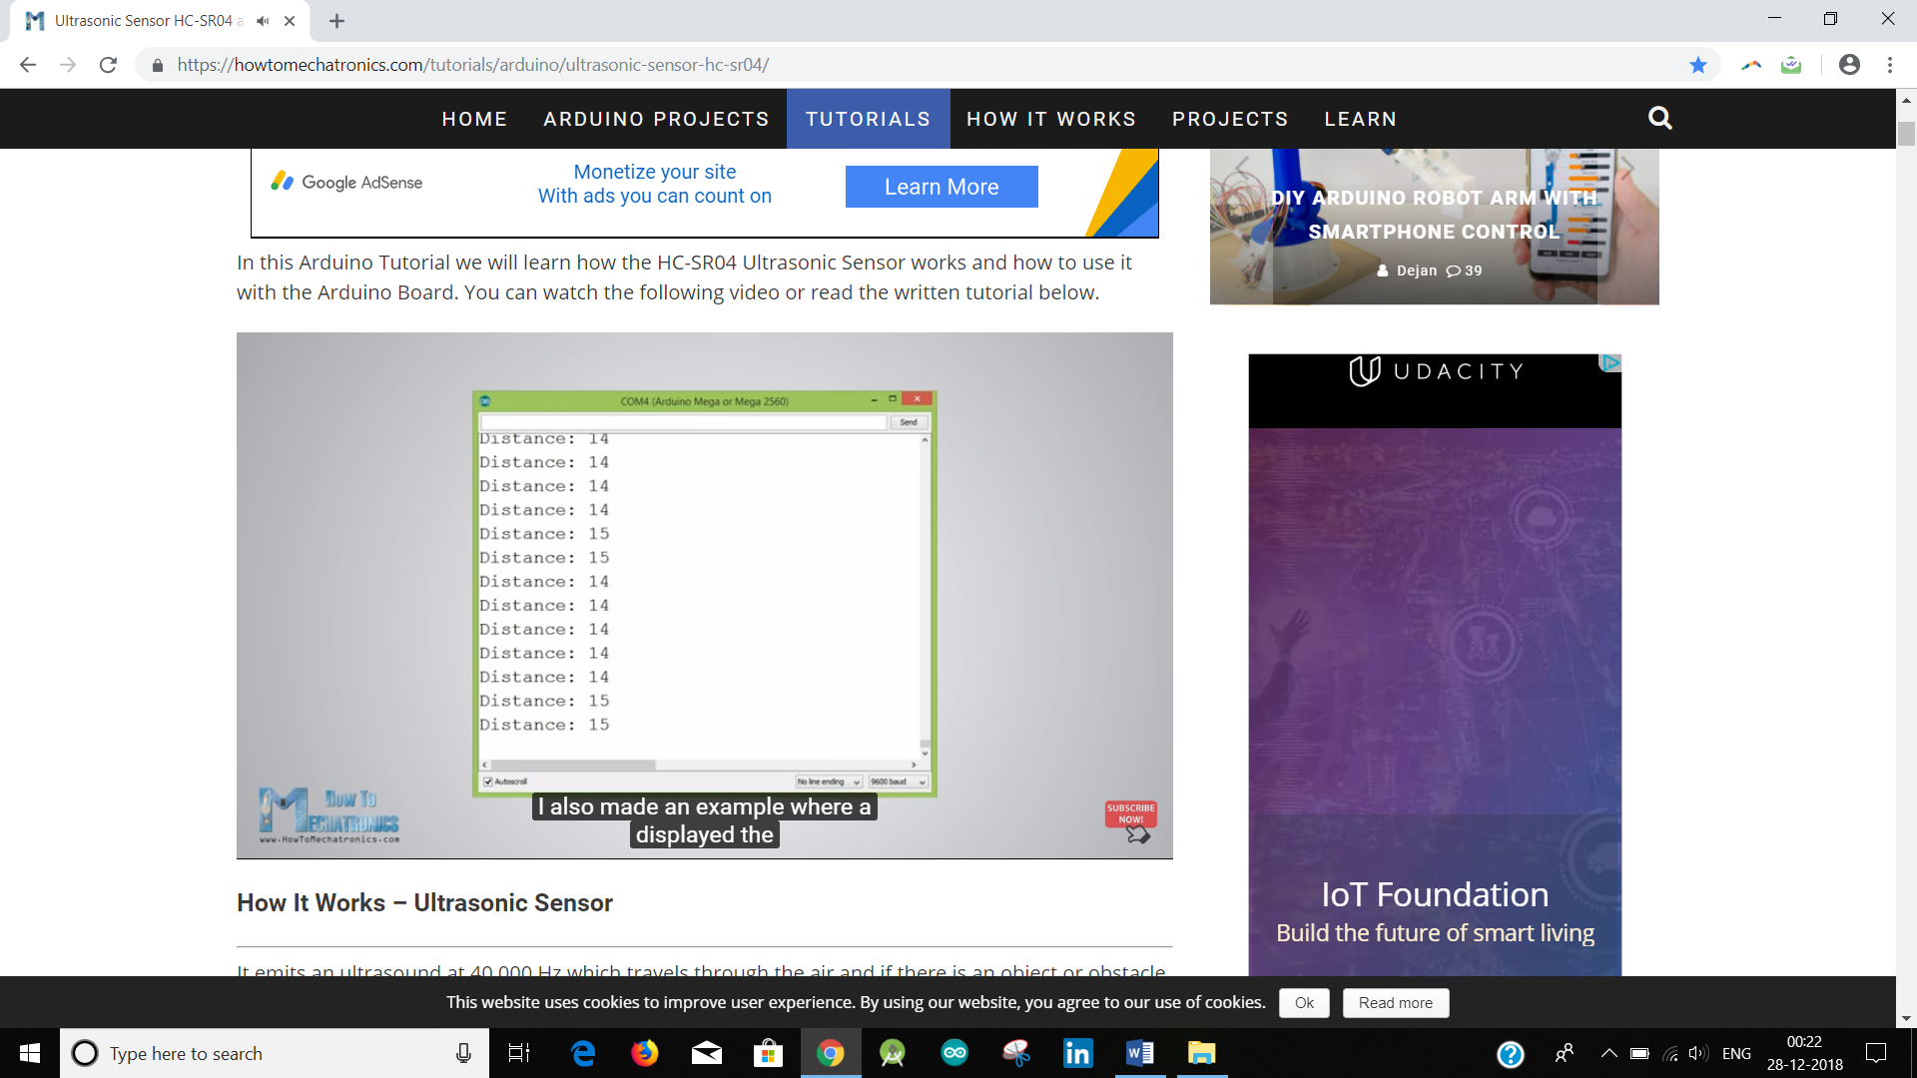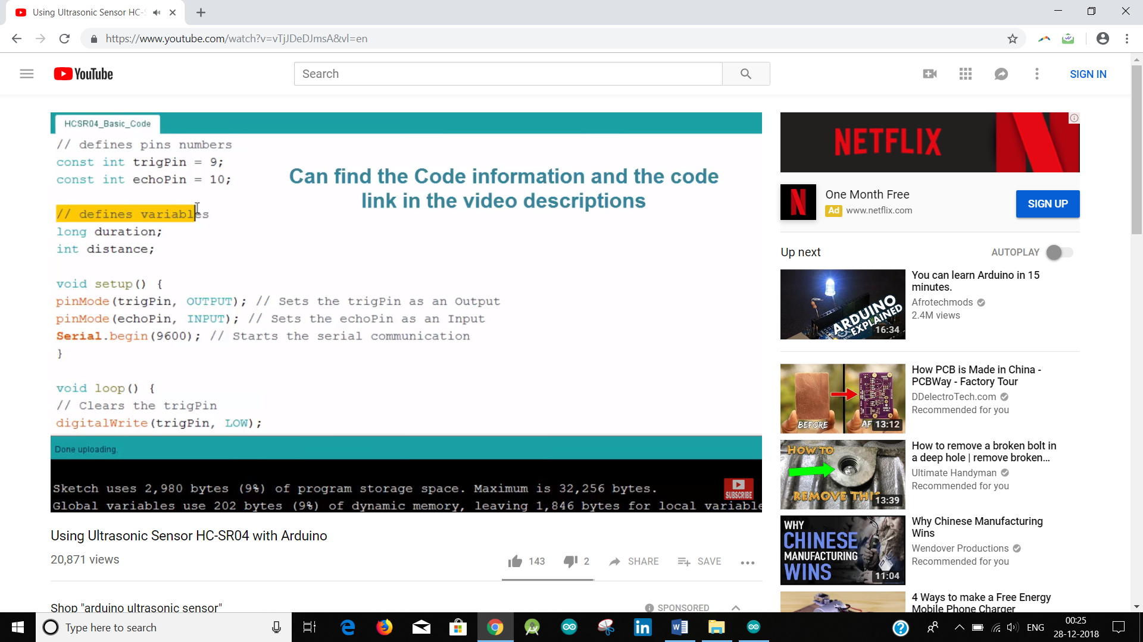

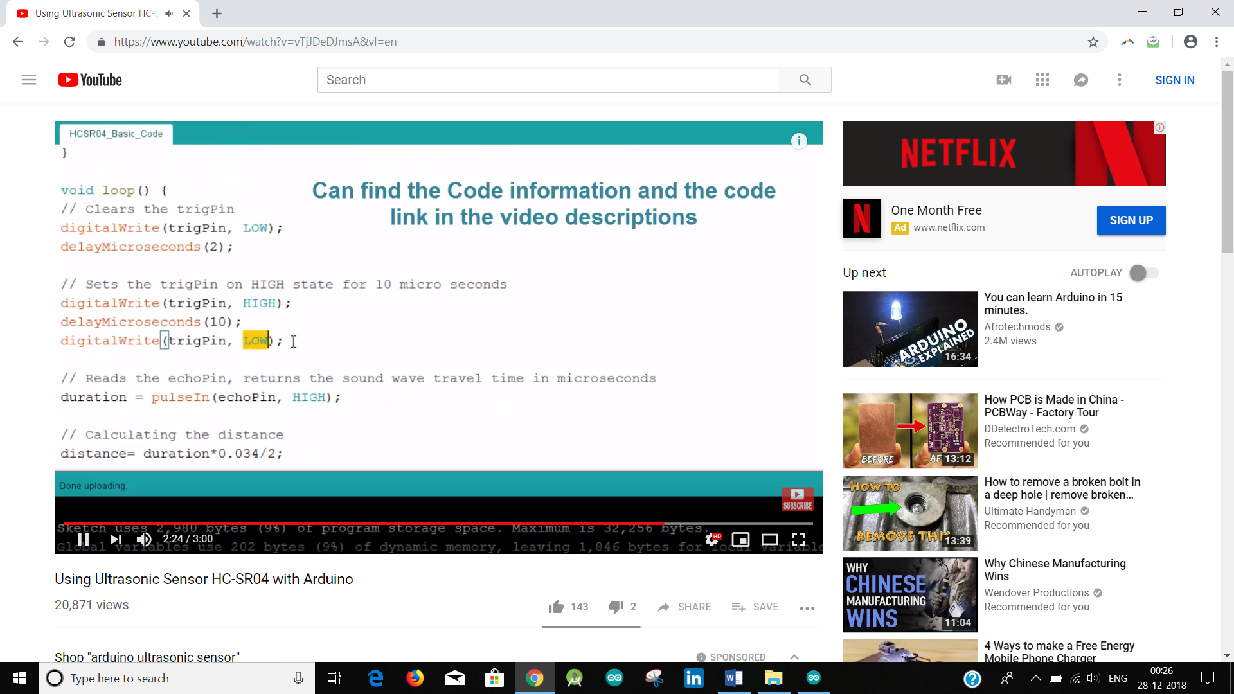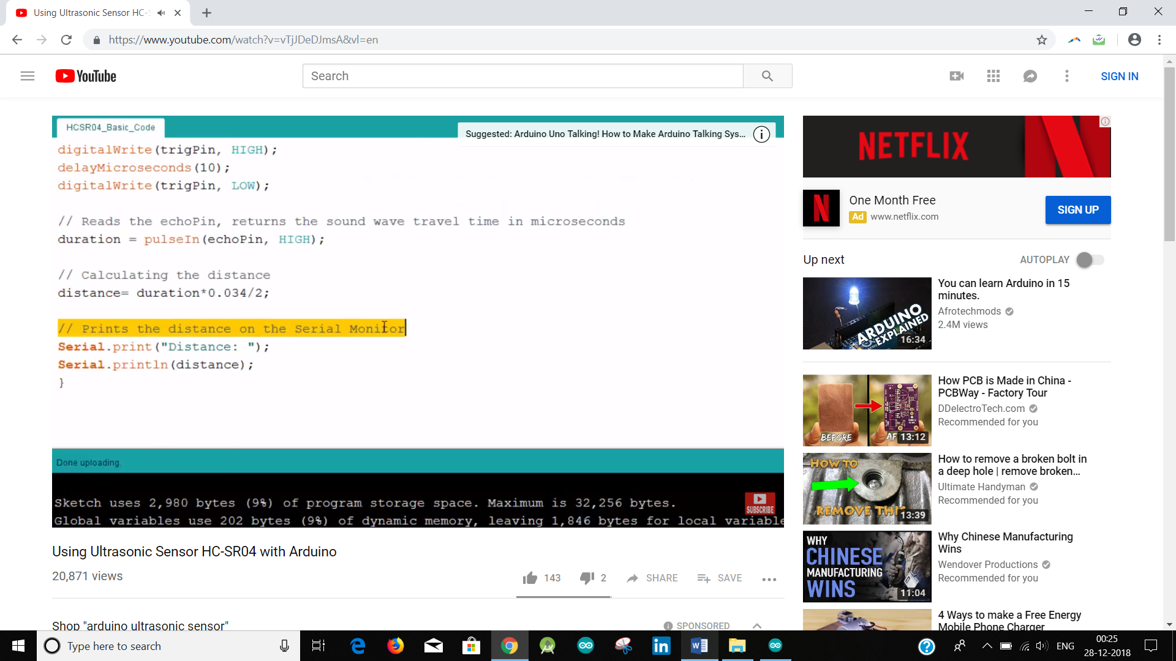

Whenever an obstacle is reached let it call a new function than typing because it is easier to track the movement and not in loop then check every time.

Note: Time duration for turning left or right is very less and delay would only make it to wait but not continuously keep turning, hence keep turning till the encoder reads some proper value such that it becomes 90 degrees.

Also once it is taking some decision, it has to stop() or give delay. Stopping is better because next decision can be taken and the program is not under pause.